CJPU Bios and Headshots
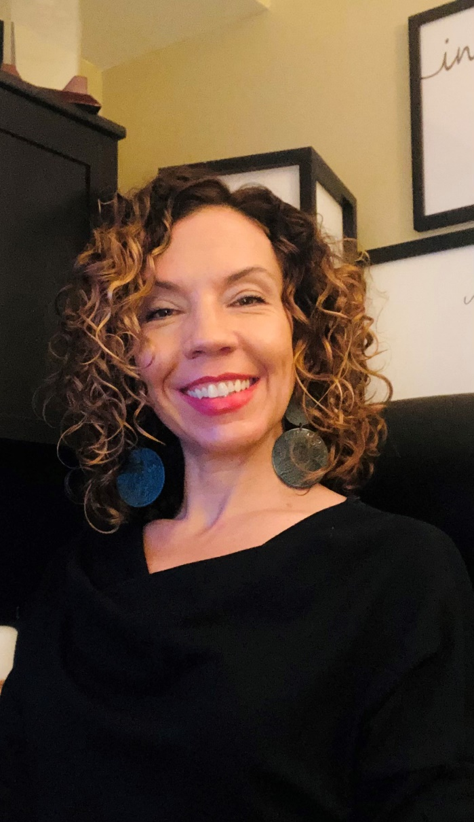
Amanda Myers:
Amanda earned her Master of Public Administration from the University of Colorado Denver (2019) and her Bachelor of Science in Criminal Justice from Metropolitan State University of Denver (2003).
She began her career in 1999 with the Jefferson County Criminal Justice Planning Office and has held roles including Diversion Counselor, TASC Case Manager, Probation Officer, and Problem-Solving Court Coordinator. From 2014 to 2019, she managed multiple specialized courts in the 18th Judicial District, including Veterans Treatment Court, Adult Drug Court, Felony DUI Court, Truancy Court, and Mental Health Court.
From 2019 to 2023, Amanda led the Forensic Support Team at the Colorado Office of Behavioral Health, overseeing statewide care coordination for individuals awaiting competency evaluation or restoration. She also served as a trainer and technical assistance consultant for All Rise and Justice for Vets, and as President of a recovery residence and board member of a veterans organization.
Amanda currently serves as the Criminal Justice Programs Unit Manager at the Colorado State Court Administrator’s Office, overseeing problem-solving courts, adult diversion, restorative justice, juvenile delinquency, and competency programs. She has completed the Behavioral Health and Justice Leadership Academy and the Rocky Mountain Leadership Academy.
Her work has been recognized with the Youth Serving Professional of the Year (2008), Judicial Excellence Award (2015), and Denver Community Beacon Award (2017). Her Forensic Support Team was nominated for the Tom Clements Award in 2020.

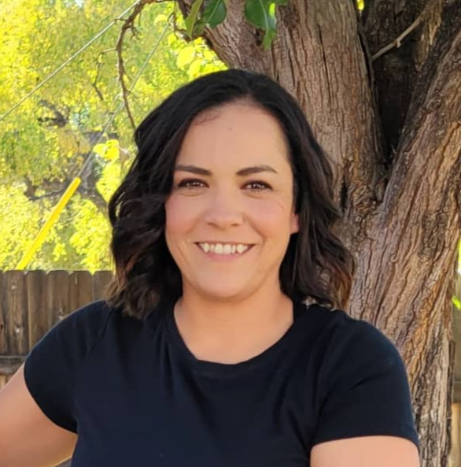
Desiree Hermocillo:

Desiree Hermocillo serves as the Statewide Problem-Solving Court Unit Manager for the Colorado Judicial Branch, where she specializes in administrative policy and procedures. With a focus on strategic planning, staff supervision, and guiding the work of Colorado Problem-Solving Courts at a statewide level, Desiree plays a pivotal role in shaping the direction and efficacy of these crucial programs. As a dynamic leader in the field of criminal justice, Desiree Hermocillo brings a wealth of expertise and passion to her role. With a keen understanding of the intersection between behavioral health and the criminal justice system, she believes in the transformative power of problem-solving courts. Through her strategic leadership and commitment to excellence, Desiree strives to ensure that the programs within the Criminal Justice Programs Unit emerge as leaders in spaces where behavioral health intersects with the legal system.

Melanie Pitkin:
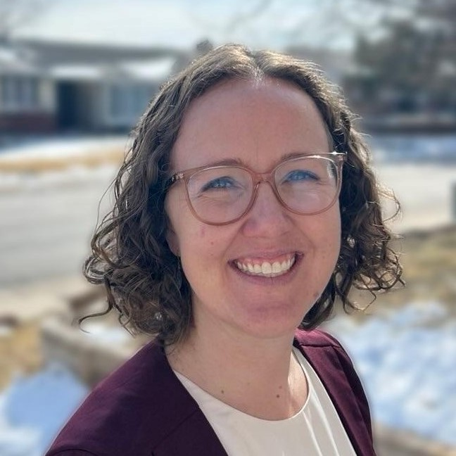
Melanie Pitkin is the Statewide Adult Diversion and Delinquency Initiatives Coordinator at the State Court Administrator’s Office. In this role, she administers state adult diversion funds and provides support to adult diversion programs. She is also facilitating a statewide evaluation of juvenile delinquency case processing, supporting juvenile competency dockets and process improvement, and expanding juvenile delinquency training opportunities. Melanie’s previous experiences include directing jail programming, providing technical assistance to state legislatures working to improve their youth and adult justice systems, and coordinating problem solving court teams in the 18th Judicial District.

