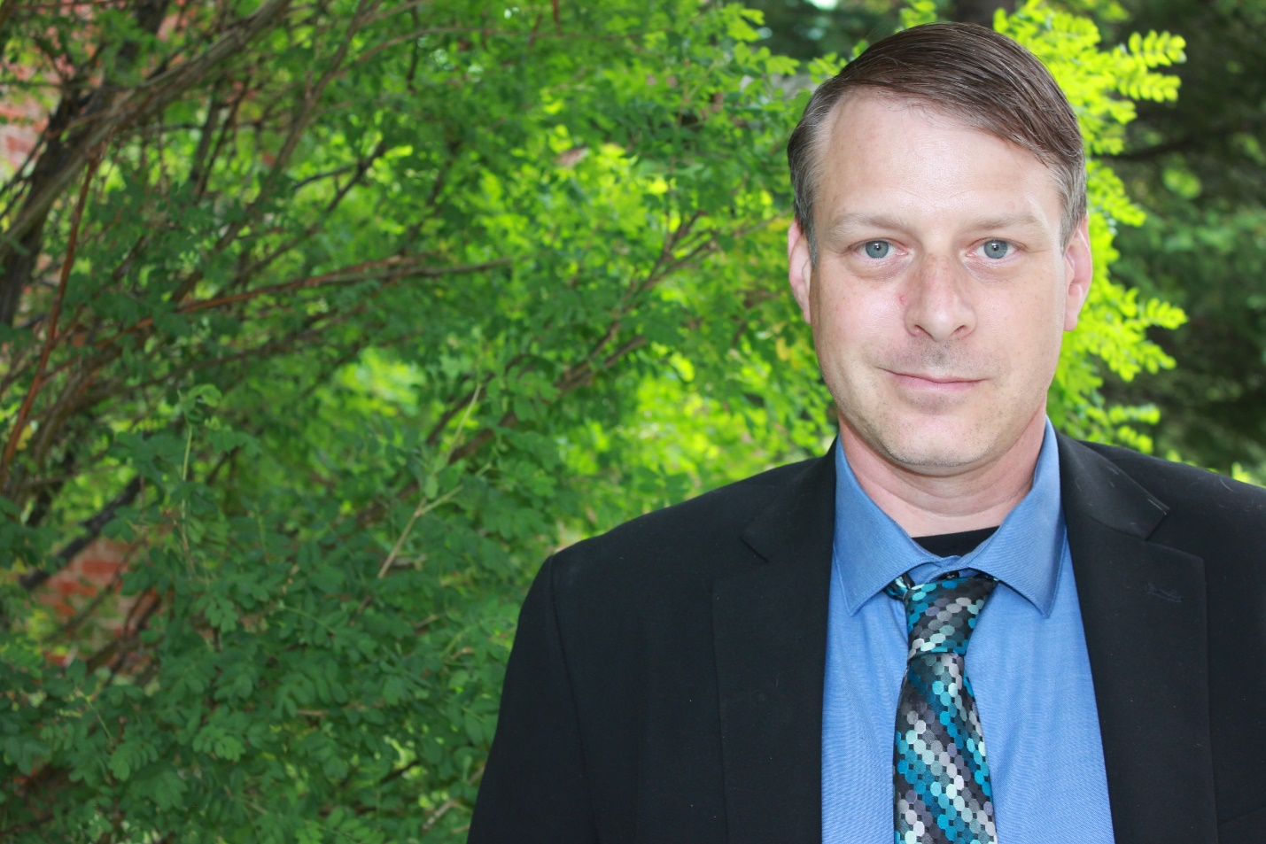
Daric Gutzwiller is a Lieutenant with the Summit County Sheriff’s Office in Colorado and serves as the supervisor of SMART (System-Wide Mental Assessment Response Team). SMART is an innovative co-responder program focused on mental health crisis intervention, emphasizing least-restrictive treatment options, direct placement pathways, diverting unnecessary criminal justice system involvement, and providing intensive ongoing case management services at no cost to clients. Daric oversees the program’s operational response, strategic development, and day-to-day management.
SMART was developed after Sheriff Jaime FitzSimons tasked Daric with studying national best practices, collaborating with community partners, and designing a crisis-response model tailored to the unique public safety and behavioral health challenges of Colorado’s high country. The program has since become a nationally recognized example of effective, compassionate crisis intervention and supportive aftercare.
Daric has worked at Summit County Sheriff’s Office for over two decades and brings experience from nearly every facet of law enforcement. Outside of work, he enjoys spending time in his machine shop listening to punk rock music, snowboarding, mushroom hunting in the mountains, and practicing precision rifle shooting on the range.

